Exhibition price record
First quarter exhibition 2019
AAR 006 | 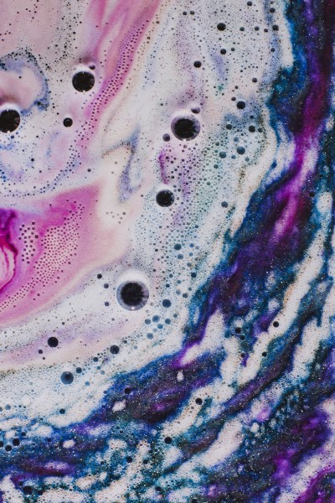 | Alexandra Archer  Tactile 6, 2016  c-print  50 x 33 cm  19 3/4 x 13 in  (AAR 006) | 0
AAR 007 | 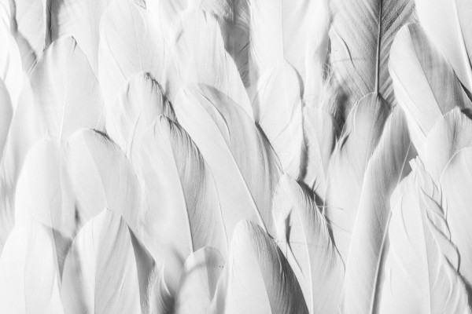 | Alexandra Archer  Tactile 7, 2016  c-print  33 x 50 cm  13 x 19 3/4 in  (AAR 007) | 0
AAR 008 | 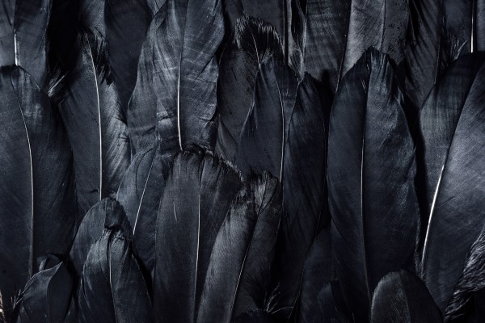 | Alexandra Archer  Tactile 8, 2016  c-print  33 x 50 cm  13 x 19 3/4 in  (AAR 008) | 0
AAR 009 | 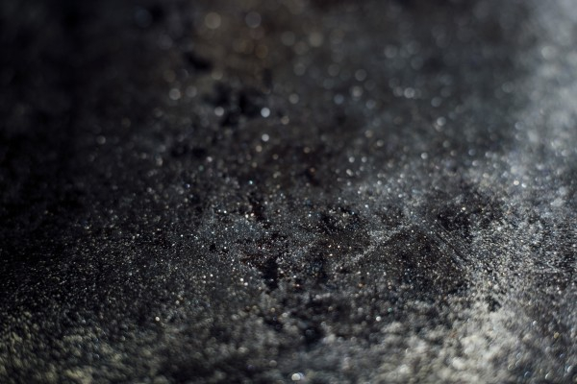 | Alexandra Archer  Tactile 9, 2016  c-print  33 x 50 cm  13 x 19 3/4 in  (AAR 009) | 0
FBR 051 | 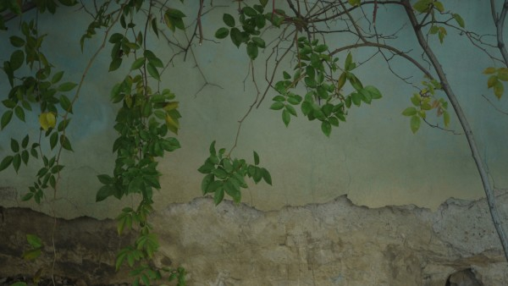 | Flora Brooke  Untitled (Florence) 1, 2012  signed, dated and numbered verso  chromogenic print  30 x 15 inches  (FBR 051) | 0
FBR 060 | 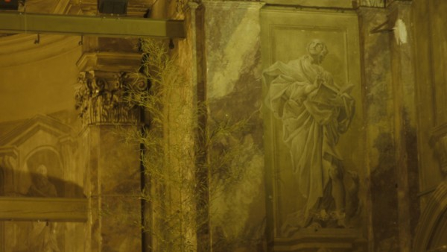 | Flora Brooke  Untitled (Florence) 10, 2012  signed, dated and numbered verso  chromogenic print  30 x 15 inches  (FBR 060) | 0
FBR 061 | 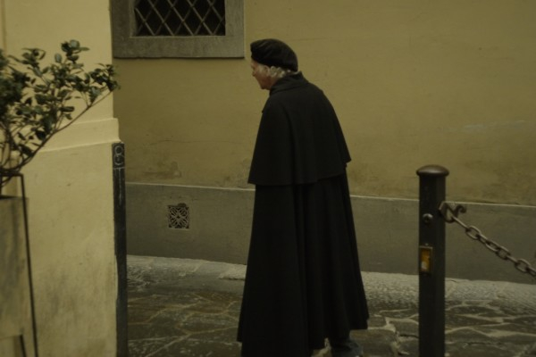 | Flora Brooke  Untitled (Florence) 11, 2012  signed, dated and numbered verso  chromogenic print  30 x 15 inches  (FBR 061) | 0
KDA 006 | 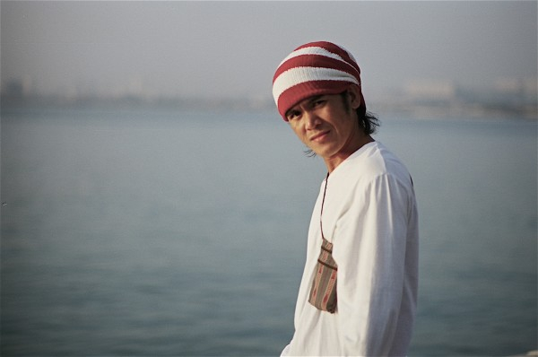 | Kadeem Darzi  Dubai Construction Workers 6, 2014  signed and numbered verso  C-type print  68 x 48 inches  edition of 6 plus 2 artist's proofs  (KDA 006) | 0
KDA 007 |  | Kadeem Darzi  Dubai Construction Workers 7, 2014  signed and numbered verso  C-type print  68 x 48 inches  edition of 6 plus 2 artist's proofs  (KDA 007) | 0
KDA 008 |  | Kadeem Darzi  Dubai Construction Workers 8, 2014  signed and numbered verso  C-type print  68 x 48 inches  edition of 6 plus 2 artist's proofs  (KDA 008) | 0
KDA 009 | 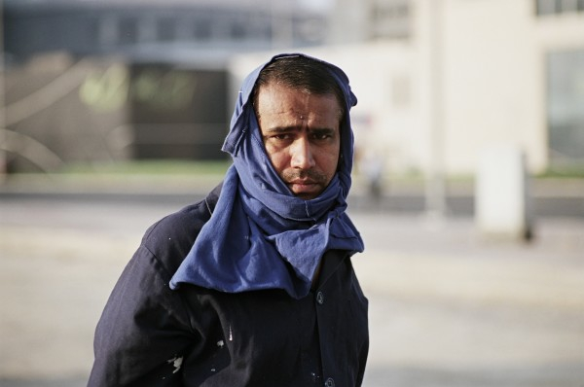 | Kadeem Darzi  Dubai Construction Workers 9, 2014  signed and numbered verso  C-type print  68 x 48 inches  edition of 6 plus 2 artist's proofs  (KDA 009) | 0
TDE 026 | 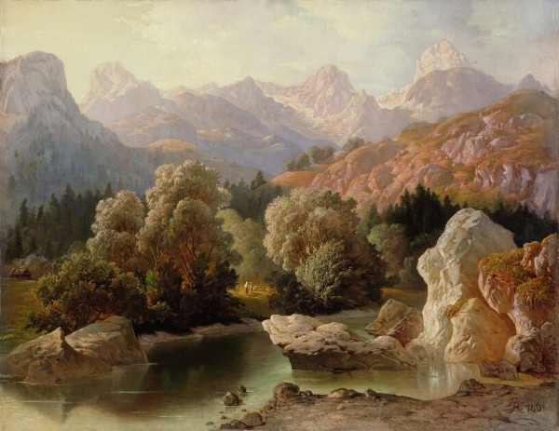 | Thomas Dedrick  Pastoral Scene, 1798  signed and dated bottom right  oil on canvas  48 x 38 inches  (TDE 026) | 0
TDE 024 | 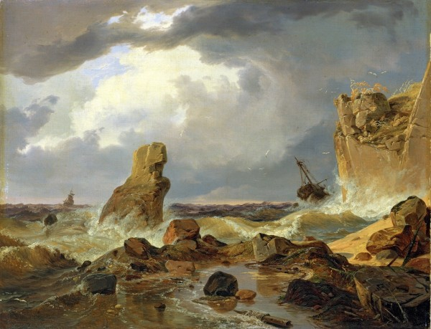 | Thomas Dedrick  Stormy Seas, 1798  signed and dated bottom right  oil on canvas  48 x 38 inches  (TDE 024) | 120,000

